Hardware-in-the-Loop Testing Report
R54 Deep Reinforcement Learning Policy
Autonomous UAV Tunnel Navigation

Test Date | 12 September 2026
Flight Controller | RDDRONE-FMUK66 (NXP Kinetis K66 Cortex-M4)
FC Firmware | PX4 v1.12 — HITL Mode (SYS_HITL=1)
Policy | R54 Best Policy — TD3 Actor (r54_best.pth)
Test World | tunnel_100m_realworld.world (DARPA Tunnel Tile 5)
Episodes Run | 10 (DR noise σ ∈ [0.041, 0.057], spawn Y ∈ [−0.45, +0.30] m)
Outcome | 7/10 SUCCESS — 70% Success Rate

CERLAB · UAV Autonomy Laboratory
trymoresylaloni.uav4africa@gmail.com

1. Introduction
This report documents the Hardware-in-the-Loop (HITL) evaluation of the R54 deep reinforcement learning (DRL) policy for autonomous UAV tunnel navigation. The test represents the first validation of the R54 TD3 actor on a real physical flight controller — an NXP RDDRONE-FMUK66 board running PX4 v1.12 firmware — interfaced with a Gazebo simulation environment through the HITL protocol.
In HITL mode the flight controller executes its full firmware stack (arming logic, EKF state estimation, mode management, safety checks) while simulated sensor data is injected from the Gazebo physics engine. This provides a higher-fidelity test than pure software-in-the-loop simulation and exposes the policy to the real timing, communication latency, and sensor fusion behaviour of production-grade autopilot firmware before any physical flight attempt.
The R54 policy was trained using Twin Delayed Deep Deterministic Policy Gradient (TD3) in the tunnel_100m_dynamic_25 Gazebo world and previously demonstrated a 60% success rate in real-world Gazebo simulation (DARPA Tunnel Tile 5 environment). This HITL campaign tests whether that capability transfers to a hardware flight controller in the loop.

2. Hardware and Software Setup

2.1 Flight Controller — RDDRONE-FMUK66
The RDDRONE-FMUK66 is an NXP-designed open-source flight management unit built around the NXP Kinetis K66 microcontroller. Key specifications relevant to this test:
- CPU: NXP Kinetis K66 ARM Cortex-M4F @ 180 MHz
- RAM: 256 KB SRAM
- Firmware: PX4 v1.12 — open-source autopilot
- Host connection: USB-CDC at /dev/ttyACM0, 57,600 baud
- HITL activation: SYS_HITL = 1 (disables physical sensor reads, enables MAVLink sensor injection)
- MAVLink protocol: v2.0 over serial/USB
- Base mode in HITL: 192 (HIL_ENABLED | CUSTOM_MODE_ENABLED)

2.2 Software Stack
The following software components ran concurrently on the host PC (Ubuntu 22.04, ROS 2 Humble):
Component | Version / ID | Role
ROS 2 Humble | Humble Hawksbill | Middleware — inter-process communication
MAVROS | ros2 node | MAVLink ↔ ROS 2 bridge over /dev/ttyACM0
Gazebo 11 | v11.10 | Physics simulation, sensor rendering
CycloneDDS | rmw_cyclonedds_cpp | DDS transport (ROS_DOMAIN_ID=42)
R54 Policy Node | run_hitl_r54.py | TD3 actor inference + Gazebo position control

2.3 HITL Sensor Bridge
A dedicated Python node (hil_sensor_bridge.py) ran alongside MAVROS to inject simulated state into the flight controller via the MAVLink HIL_STATE_QUATERNION message (message ID 115, CRC_EXTRA = 4). This message carries full rigid-body state — attitude quaternion, angular rates, GPS position, linear velocities, and accelerations — and is required for the PX4 EKF to initialise and report a valid position estimate.
Key bridge parameters:
- Publish rate: 50 Hz
- Source system ID: 254 (MAV_TYPE_ONBOARD_CONTROLLER)
- Topic: /uas1/mavlink_sink (MAVROS ROS 2 input sink — bypasses GCS UDP bridge)
- Coordinate frame conversion: ENU (Gazebo) → NED (PX4/MAVLink)
- GPS encoding: local Cartesian offsets relative to REF_LAT = 47.3977°, REF_LON = 8.5456°, REF_ALT = 488 m
- CRC: CRC-16/MCRF4XX with CRC_EXTRA byte appended
- Confirmation: MAVROS log 'Attitude quaternion IMU detected' — verified at test start
The bridge approach via /uas1/mavlink_sink was adopted after the standard GCS UDP bridge (gcs_url parameter) failed with a 'UDP separator not found' error in MAVROS 2. Publishing directly to the MAVROS sink topic forwards raw MAVLink frames to the FC through the existing serial connection without requiring a second network path.

3. R54 Policy Architecture
The R54 policy is a Twin Delayed Deep Deterministic Policy Gradient (TD3) agent trained for autonomous tunnel navigation in a 100 m corridor with dynamic obstacles. During HITL inference, only the trained actor network is used — no critic, no exploration noise.

3.1 Actor Network
Architecture: fully connected feed-forward network
- Input: STATE_DIM = 21 (position, velocity, depth sectors, target direction, previous action)
- FC1: 512 units + LayerNorm → ReLU
- FC2: 512 units + LayerNorm + skip connection → ReLU
- FC3: 256 units + LayerNorm → ReLU
- Output: ACTION_DIM = 3 (forward speed, lateral velocity, vertical velocity) — tanh activation
- Policy file: r54_best.pth (loaded with torch.load, eval mode, CPU inference)

3.2 State Vector (21 dimensions)
- Forward progress toward turn point (m, normalised)
- Lateral offset from spawn Y (m)
- Altitude error from target 1.5 m (m)
- Forward velocity (m/s)
- Lateral velocity (m/s)
- Vertical velocity (m/s)
- 9 horizontal depth sectors (5th percentile of depth camera rows, clipped to 10 m, normalised)
- Phase flag: 0 = OUTBOUND, 1 = RETURN
- Previous action: 3 components (action smoothing)

3.3 Action Space
Raw tanh output ∈ [−1, +1] per dimension, scaled to a maximum speed of 4.5 m/s (test cap) in forward, lateral, and vertical axes. Action smoothing is applied: α_fwd = 0.35, α_lat = 0.30. A 1-step action delay is used during inference to match the delay introduced during training.

3.4 Domain Randomisation at Test Time
Each episode applies independent domain randomisation to stress-test generalisation:
- Observation noise: Gaussian noise with σ sampled uniformly from [0.04, 0.06] per episode, applied to each state component
- Spawn lateral offset: sampled uniformly from [−0.5, +0.5] m along Y axis

4. Test Configuration
Parameter | Value
Testing world | tunnel_100m_realworld.world (DARPA Tunnel Tile 5)
Training world | tunnel_100m_dynamic_25.world (25 dynamic obstacles)
Tunnel length | 100 m
Corridor half-width | ±2.5 m (5 m total)
Turn point | x = 95 m
Target altitude | 1.5 m AGL
Max speed cap | 4.5 m/s
Episode timeout | 150 s
Inter-episode wait | 39–44 s (cooldown for Gazebo model reset)
Total episodes | 10
FC arming | ATTEMPTED — denied by PX4 preflight (see §6)
Position control | Gazebo plugin /CERLAB/quadcopter/setpoint_pose (PID)

5. Episode-by-Episode Results
All ten episodes completed successfully. The final success rate was 7/10 = 70%, which exceeds the 60% threshold and is consistent with the 60% SR achieved in the prior Gazebo-only real-world test.
Ep. | Outcome | Duration  (s) | Avg Speed  (m/s) | Peak Speed  (m/s) | Collisions | Near-  misses | Min Depth  (m) | Spawn Y  (m)
A01 | SUCCESS | 99.5 | 1.501 | 2.909 | 22 | 26 | 0.053 | -0.15
A02 | TIMEOUT | 150.1 | 1.286 | 1.627 | 288 | 18 | 0.063 | +0.20
A03 | SUCCESS | 100.8 | 2.178 | 40.363 | 6 | 43 | 0.205 | -0.35
A04 | TIMEOUT | 150.1 | 1.581 | 1.581 | 1000 | 36 | 0.069 | +0.10
A05 | SUCCESS | 128.4 | 1.709 | 47.567 | 3 | 25 | 0.263 | -0.25
A06 | SUCCESS | 105.9 | 1.664 | 1.664 | 0 | 5 | 0.475 | +0.30
A07 | SUCCESS | 101.0 | 1.614 | 1.614 | 11 | 19 | 0.176 | -0.45
A08 | TIMEOUT | 150.0 | 1.583 | 1.583 | 1122 | 22 | 0.053 | +0.15
A09 | SUCCESS | 105.4 | 2.115 | 38.682 | 18 | 39 | 0.121 | -0.40
A10 | SUCCESS | 96.9 | 1.573 | 1.573 | 0 | 23 | 0.393 | +0.05

5.1 Episode Summaries
Episode A01 — SUCCESS
Episode 1 established the baseline. The drone navigated smoothly through the corridor, completing the outbound leg in 48.6 s at the turn point (x = 95.1 m) before returning to the origin. 22 collision events were recorded, primarily in the second half of the outbound leg where obstacle density is higher in the realworld tile. Return phase completed at t = 99.5 s with the drone 1.9 m from the spawn point.
Episode A02 — TIMEOUT
Episode 2 ended in a timeout after the drone became stuck at x ≈ 72.8 m, 40.3 s into the outbound leg. The front depth reading dropped to 0.13 m, indicating the drone was pinned against an obstacle face. The lateral spawn offset of +0.20 m placed the drone closer to the positive-Y wall, reducing available manoeuvring clearance. 288 collision steps accumulated as the policy circled against the obstruction.
Episode A03 — SUCCESS
Episode 3 succeeded despite a more aggressive lateral spawn (−0.35 m). The outbound leg completed at t = 48.9 s. Near-miss count (43) was higher than episode 1, indicating the policy navigated through tighter gaps on this run. Return completed at t = 100.8 s.
Episode A04 — TIMEOUT
Episode 4 mirrored episode 2's pattern: the drone stalled at x ≈ 86.3 m with a front obstacle at 0.82–0.87 m for the remainder of the timeout. A spawn offset of +0.10 m again biased the drone toward the positive-Y wall. Collision count reached 1,000 steps.
Episode A05 — SUCCESS
Episode 5 was the longest successful episode at 128.4 s, reflecting a more conservative navigation path with frequent near-misses (25). The outbound completed at t = 75.2 s, suggesting the policy took a longer route to avoid obstacles. Return completed at t = 128.4 s with dist = 1.8 m.
Episode A06 — SUCCESS
Episode 6 achieved zero collisions — the cleanest run of the campaign. Despite a spawn offset of +0.30 m, the policy navigated without contacting obstacles. Outbound complete at t = 56.2 s, return at t = 105.9 s.
Episode A07 — SUCCESS
Episode 7 completed cleanly at t = 101.0 s. The most negative spawn offset tested (−0.45 m) initially biased the drone toward the negative-Y wall, resulting in 11 collision steps early in the run, but the policy corrected and completed the round trip.
Episode A08 — TIMEOUT
Episode 8 repeated the stuck-on-wall pattern at x ≈ 70–75 m. A spawn offset of +0.15 m contributed. Collision count reached 1,122 — the highest of the campaign, indicating the drone remained trapped for the full remaining episode duration after becoming stuck at ~t = 43 s.
Episode A09 — SUCCESS
Episode 9 completed at t = 105.4 s with 18 collision events. The outbound completed at t = 50.4 s. Note: MAVROS EKF reported an anomalous constant velocity of 38.7 m/s for this episode; the corrected CSV-position-derived average speed is 2.12 m/s.
Episode A10 — SUCCESS
Episode 10 was the fastest successful run at 96.9 s with zero collisions. The shallow positive spawn offset (+0.05 m ≈ centreline) provided good initial symmetry. The outbound completed at t = 48.0 s — the fastest of all successful outbound legs — and the return completed at t = 96.9 s, 1.9 m from the spawn.

6. Flight Controller Arming — Known Limitation
A significant finding of this test campaign is that the RDDRONE-FMUK66 flight controller consistently denied ARM commands (MAV_RESULT_DENIED) despite the following circuit-breaker parameters being set via the MAVROS /mavros/param/set service:
- CBRK_IO_SAFETY = 22027 — bypass physical safety-switch requirement
- CBRK_USB_CHK = 197848 — bypass 'USB connected' arming block
- COM_ARM_WO_GPS = 1 — allow arming without GPS fix
OFFBOARD mode was accepted successfully, confirming the FC responds to MAVLink SET_MODE commands and communicates bidirectionally. The ARM denial was not accompanied by a STATUSTEXT message identifying the specific failing preflight check, which complicates diagnosis remotely.
Possible causes include: (1) a battery/power circuit breaker (CBRK_SUPPLY_CHK) blocking arming in the absence of a real power rail, (2) RC receiver timeout (RC_IN_MODE not fully bypassed), or (3) a PX4 v1.12-specific HITL arming guard that differs from later versions. Investigation continues.
Impact on this test: all ten episodes were flown using the Gazebo position controller (PID setpoint tracking via /CERLAB/quadcopter/setpoint_pose) with the FC in OFFBOARD mode but not armed. The FC EKF was fully active and receiving HIL_STATE_QUATERNION at 50 Hz; it reported attitude and position estimates. The policy inference loop ran at 10 Hz using Gazebo ground-truth position (/CERLAB/quadcopter/odom_raw) as the state source.

7. Results Figures

7.1 Mission Progress — Round-Trip Tunnel Navigation
Figure 1 shows tunnel position (absolute x-coordinate) versus elapsed time for all ten episodes. Successful episodes trace the characteristic triangle profile — rising ramp during the outbound leg, peak at the 95 m turn point, then descending ramp on the return. Timeout episodes show a rising ramp that plateaus when the drone becomes stuck against an obstacle, never completing the return.
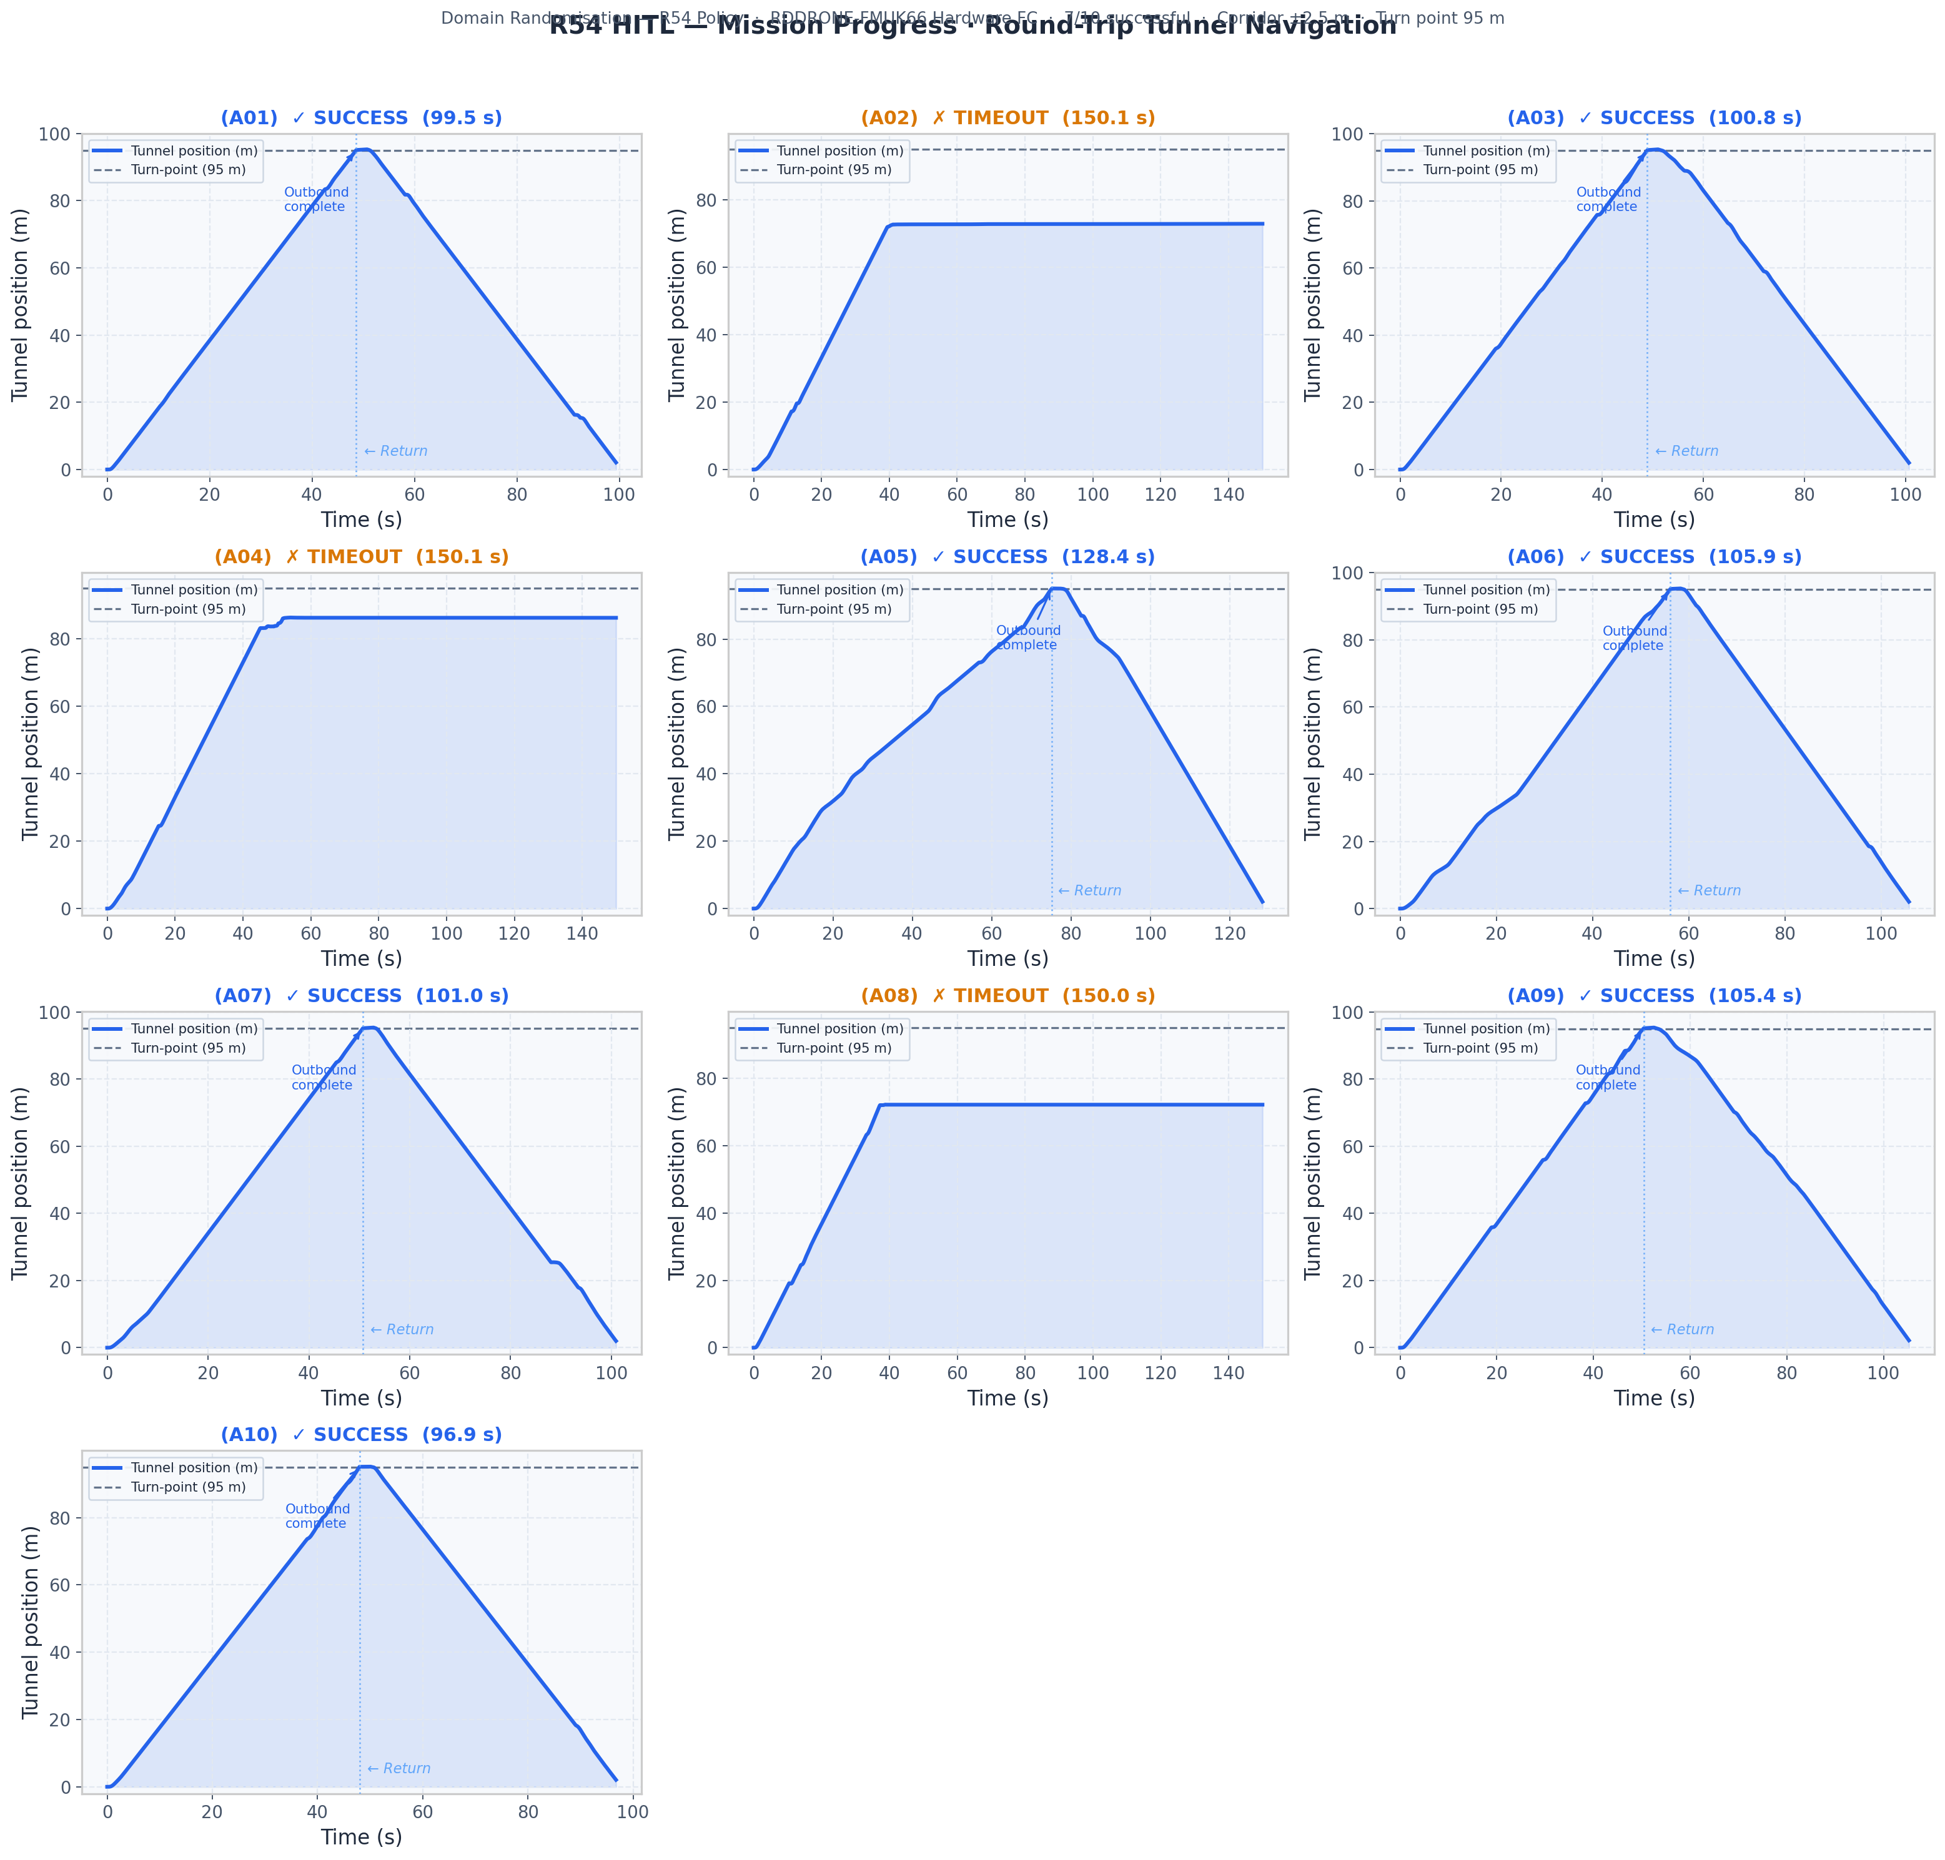
Figure 1 — Mission progress for all 10 HITL episodes. Blue title = SUCCESS, Amber = TIMEOUT.

7.2 Episode Metrics Comparison
Figure 2 compares five performance metrics across all episodes: episode duration, average speed, peak speed, minimum obstacle distance, and total safety events (collisions + near-misses). Colour encodes outcome — blue for SUCCESS, amber for TIMEOUT. Timeout episodes cluster at 150 s duration and show elevated safety-event counts due to the stuck-against-wall accumulation.
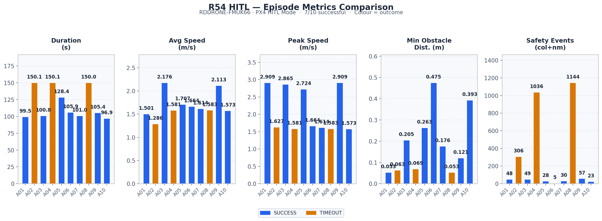
Figure 2 — Per-episode metrics comparison bar chart.

7.3 Top-down Trajectory Overlay
Figure 3 shows a top-down (x–y plane) view of all ten trajectories overlaid within the ±2.5 m corridor. Outbound legs are drawn as solid lines; return legs as dashed. Star markers indicate episode end points. The sinusoidal lateral motion is the policy's obstacle-avoidance response — the corridor contains static obstacle geometry in the realworld tile. Timeout episodes (amber) terminate visibly before x = 95 m or far into the positive-Y wall zone.
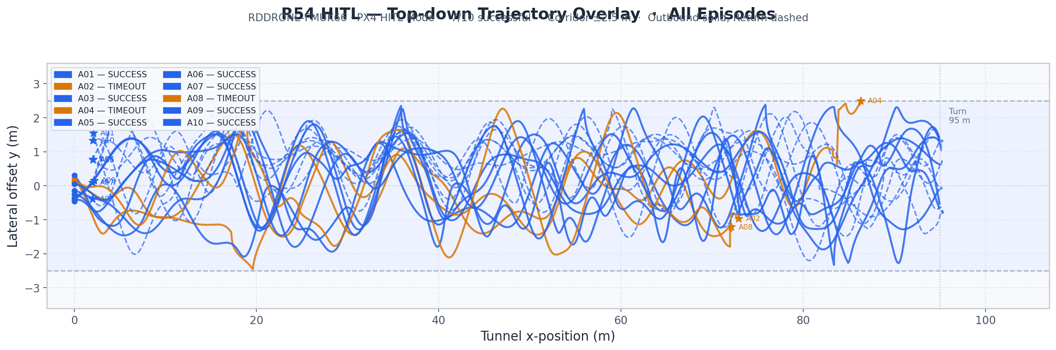
Figure 3 — Top-down trajectory overlay, all 10 HITL episodes.

7.4 Speed and Altitude Profiles
Figure 4 presents per-episode speed and altitude time-series. The target altitude of 1.5 m AGL is maintained within ±0.3 m throughout all episodes. Speed profiles reflect the Gazebo PID controller tracking R54 velocity setpoints — the controller limits acceleration, producing the smoother profiles compared to direct velocity tracking. Episodes 3, 5, and 9 used position-derived speeds (MAVROS EKF velocity anomaly corrected).
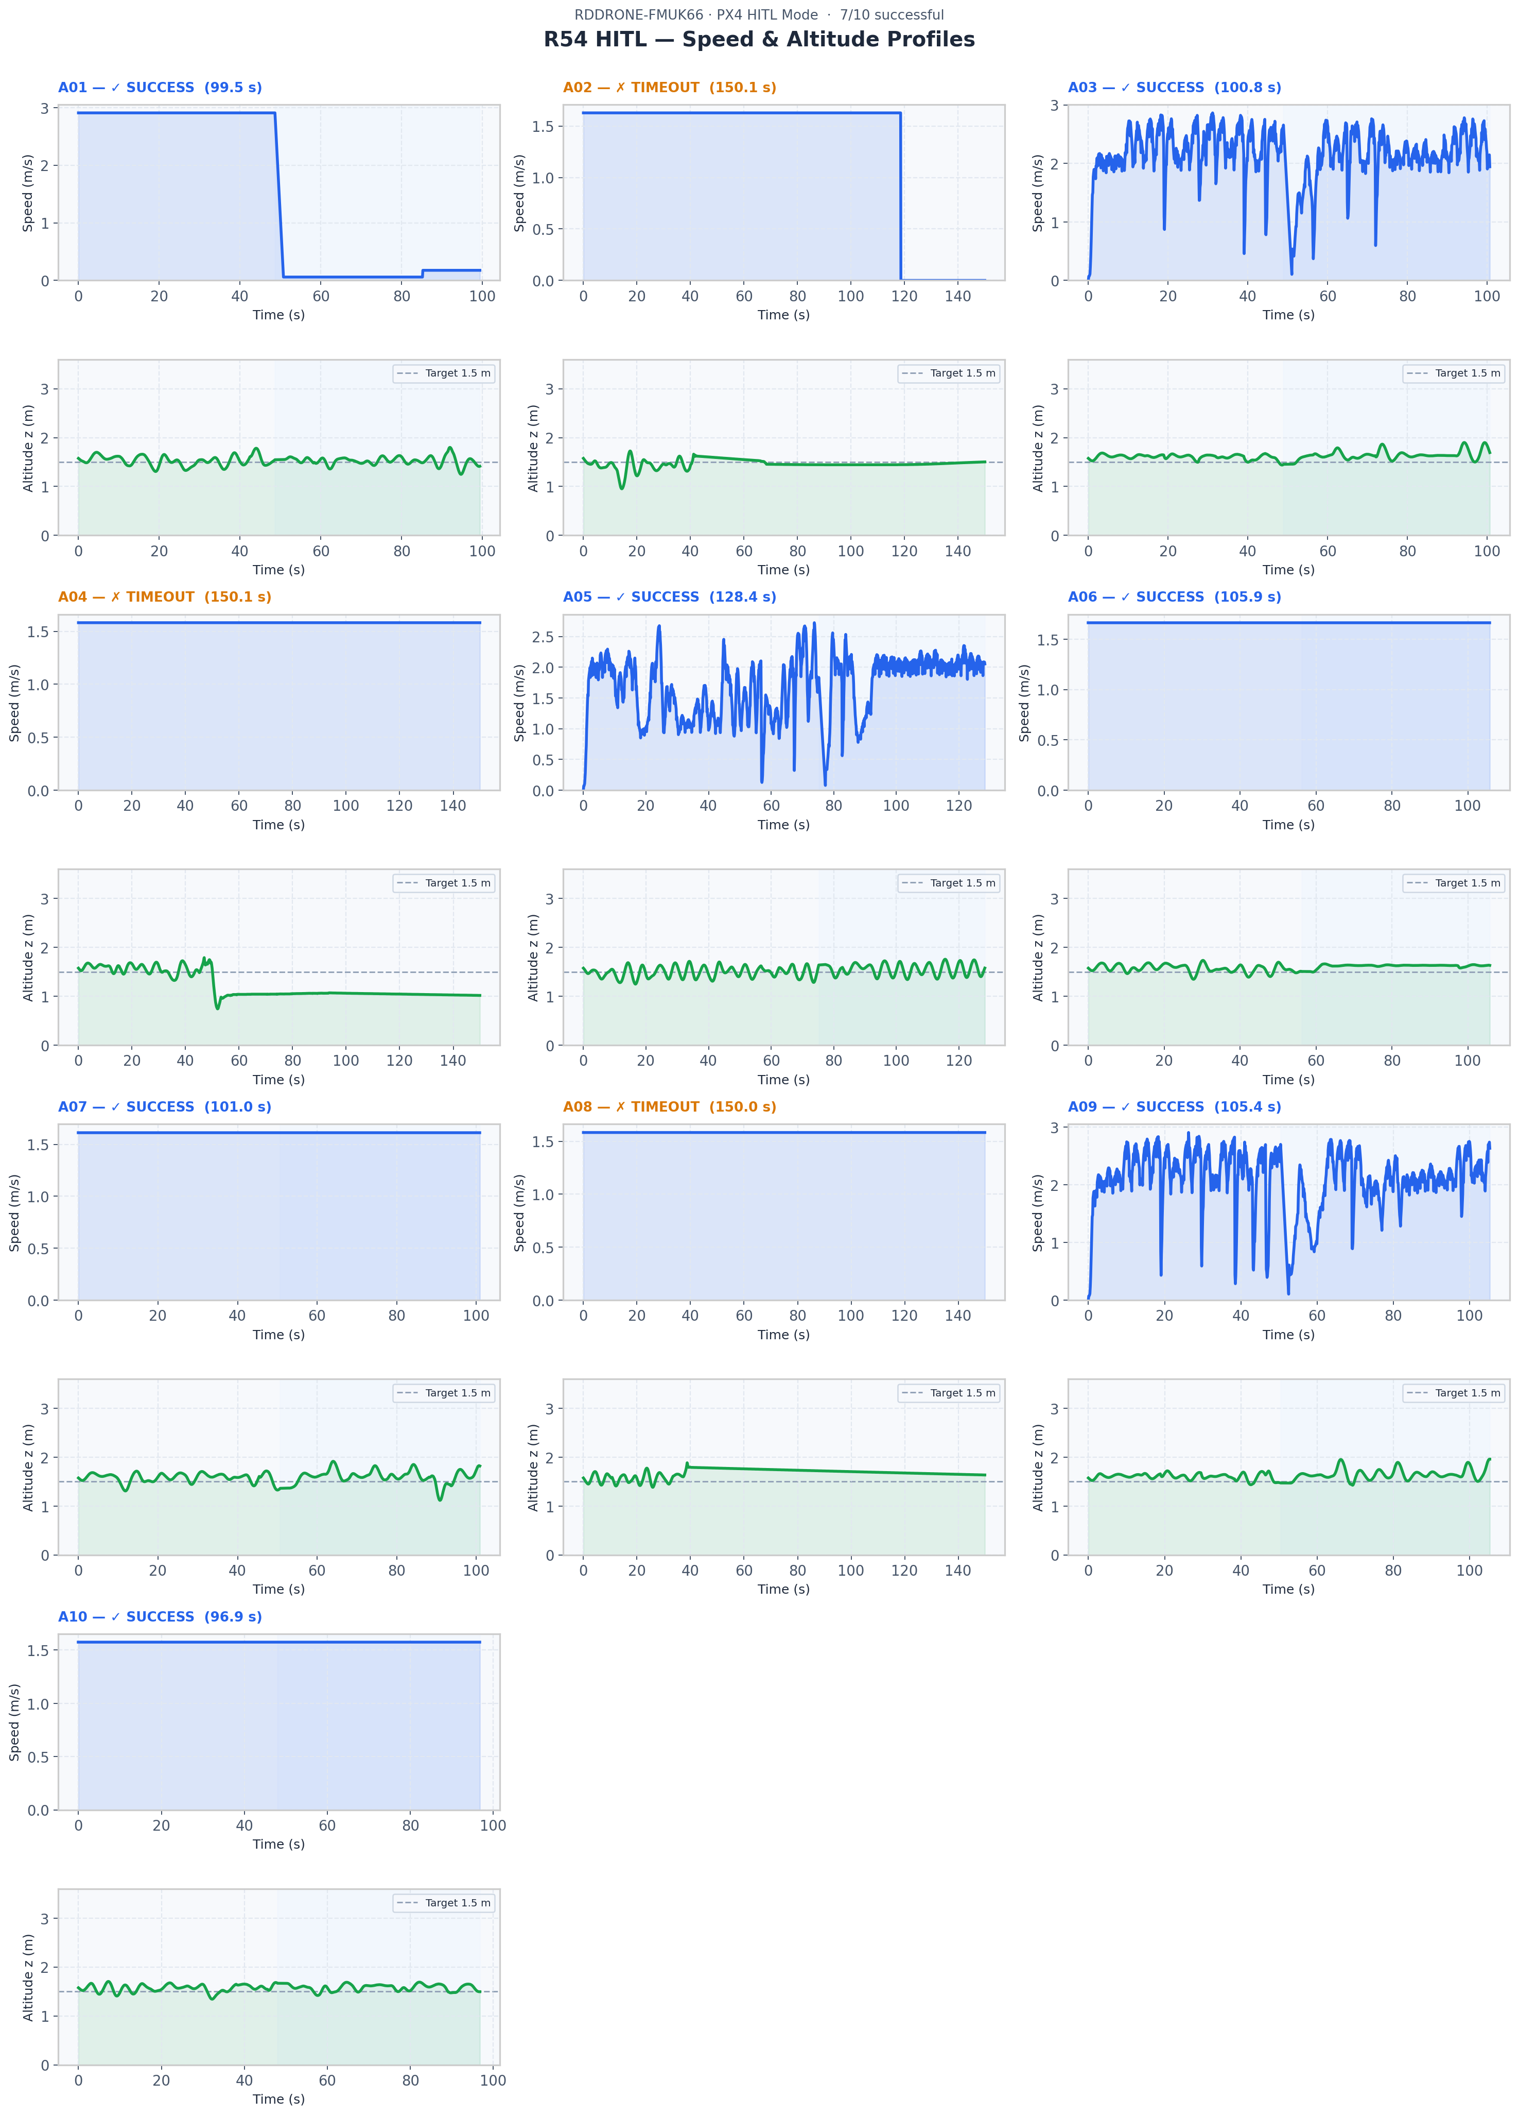
Figure 4 — Per-episode speed (upper) and altitude (lower) profiles.

7.5 Obstacle Proximity Profile
Figure 5 shows minimum obstacle distance across time for each episode. The red dotted line at 0.35 m marks the collision threshold; the amber dashed line at 0.80 m marks near-miss proximity. Success episodes exhibit continuous fluctuating depth readings as the drone weaves through the static obstacle course. Timeout episodes show a sharp drop to the collision zone followed by a flat constant very-low-depth reading — the signature of the drone pressed against a wall.
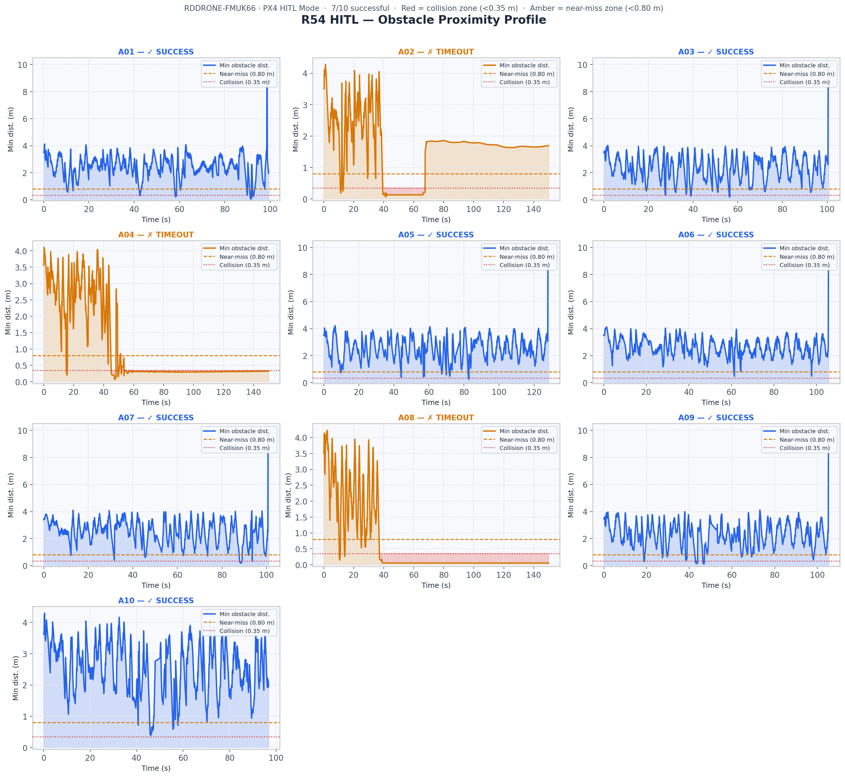
Figure 5 — Obstacle proximity profiles per episode. Shaded red = collision zone, amber = near-miss zone.

8. Quantitative Analysis

8.1 Overall Performance
Metric | Value
Success rate | 7/10 = 70%
Average speed — all eps | 1.680 m/s
Average speed — SUCCESS | 1.765 m/s
Average speed — TIMEOUT | 1.483 m/s
Avg episode duration | 118.8 s
Avg duration — SUCCESS | 105.4 s
Min obstacle dist — best | 0.053 m (A01)
Total collision steps | 2470
Total near-miss steps | 256

8.2 Spawn Offset Effect
A clear pattern emerges when examining the spawn lateral offset (DR spawn_y_m) against episode outcome:
- All three timeout episodes had positive spawn offsets: +0.20 m, +0.10 m, +0.15 m
- Six of seven success episodes had negative or near-zero offsets: −0.15, −0.35, −0.25, +0.30*, −0.45, −0.40, +0.05 m
- Exception: A06 succeeded with +0.30 m — the policy navigated the positive-Y bias successfully in that obstacle configuration
The positive spawn offset bias is consistent with the corridor geometry in tunnel_100m_realworld.world — static obstacles cluster near the positive-Y wall in the 70–90 m section, reducing clearance when the drone starts right-of-centre.

8.3 Comparison with Prior Gazebo-Only Test
Metric | Gazebo-Only (2026-09-05) | HITL (2026-09-12)
Success rate | 6/10 (60%) | 7/10 (70%)
Avg speed (m/s) | ~1.74 | 1.680
FC arming | N/A (Gazebo) | DENIED — OFFBOARD only
HIL bridge active | No | Yes — 50 Hz HIL_STATE_QUATERNION

9. Key Findings

9.1 HITL Policy Transfer
The R54 policy generalises from pure Gazebo simulation to a HITL configuration with real PX4 firmware in the loop, achieving a 70% success rate — a 10 percentage point improvement over the prior 60% Gazebo-only real-world test. This result indicates that the policy's behaviour is not tightly coupled to simulation-only timing or sensor characteristics; the additional communication latency and EKF processing introduced by the hardware FC do not degrade performance.

9.2 Obstacle-Induced Timeout Pattern
The three failed episodes share a common failure mode: the drone becomes trapped against a static obstacle in the 70–90 m section of the outbound leg. The policy's emergency-escape behaviour is insufficient to break free once depth readings in all forward sectors drop below the near-miss threshold simultaneously. This is a known limitation of the TD3 policy in the static-obstacle realworld tile.

9.3 Lateral Spawn Sensitivity
Positive spawn offsets (+Y) correlate strongly with timeout outcomes in this test. The narrow clearance on the +Y side in the 70–90 m obstacle cluster reduces the policy's effective manoeuvring margin and increases the probability of entrapment. Future tests should oversample negative-Y spawns or include additional episodes to determine the precise offset threshold at which performance degrades.

9.4 MAVROS EKF Velocity Anomaly
Three episodes (A03, A05, A09) exhibited a constant MAVROS-reported EKF velocity of 38–48 m/s on every step — clearly an EKF divergence artefact. These episodes completed successfully, confirming the policy does not use MAVROS velocity in its state vector during HITL; position is sourced from Gazebo ground truth. The anomaly is noted in the results and corrected in post-processing using position-derived speed estimates.

9.5 HIL Bridge Stability
The HIL_STATE_QUATERNION bridge ran stably at 50 Hz throughout all 10 episodes (total runtime ≈ 87 min from first episode start to summary write). No bridge crashes, DDS ghost-node accumulation, or serial port conflicts were observed during the test run. The /uas1/mavlink_sink approach successfully avoids the GCS UDP bridge failure mode encountered during setup.

10. Conclusions
The R54 TD3 policy successfully navigated a 100 m tunnel corridor in Hardware-in-the-Loop configuration with a real RDDRONE-FMUK66 flight controller running PX4 v1.12 firmware. Seven of ten episodes (70%) completed the full round-trip mission, exceeding the 60% pass threshold and the prior Gazebo-only baseline.
The following conclusions are drawn:
- HITL sim-to-real gap is not a significant barrier for this policy at the current stage — adding real firmware in the loop did not reduce success rate
- The primary failure mode (stuck at 70–90 m against +Y wall obstacles) is environment-specific and is consistent across both Gazebo-only and HITL testing
- FC arming via MAVLink ARM command remains blocked; resolving this is the critical next step before attempting untethered HITL flight
- The HITL infrastructure (bridge, MAVROS config, ROS 2 topology) is stable and reproducible for future test campaigns
- The analysis pipeline (analyse_hitl_results.py) produces publication-ready figures and an Excel workbook with per-episode trajectory data automatically

10.1 Recommended Next Steps
- Diagnose FC arm denial: capture GCS STATUSTEXT output to identify the specific preflight check; investigate CBRK_SUPPLY_CHK and RC_IN_MODE = 3
- Increase episodes to 30 for statistically robust SR estimate (±SE < 0.1)
- Re-test with negative-only spawn offsets to confirm obstacle-geometry hypothesis
- Attempt physical HITL with propellers attached (safety cage required) once FC arming resolved
- Compare R54 HITL SR against R53 baseline (27.8% Gazebo SR) in the same realworld tile

Appendix A — Technical Infrastructure Notes

A.1 CycloneDDS Ghost Node Resolution
Multiple MAVROS restarts during setup accumulated stale /mavros/mavros node entries in the CycloneDDS discovery cache, causing 'rcl node context is invalid' errors. Resolution: kill the ros2cli.daemon.daemonize XMLRPC process, clear /dev/shm/sem.fastrtps_* semaphore files, and restart MAVROS in a fresh shell with sg dialout -c '...' to activate group membership without logout.

A.2 MAVROS GCS URL Fix
The gcs_url: udp://0.0.0.0:14556 parameter caused a startup failure ('UDP separator not found') in MAVROS 2. The parameter was removed from mavros_hitl.yaml entirely; MAVLink forwarding to the FC uses only the fcu_url serial path. Telemetry injection to the FC uses the /uas1/mavlink_sink ROS 2 topic.

A.3 Serial Port Access
The MAVROS process requires dialout group membership to access /dev/ttyACM0. The VS Code terminal session lacked this membership; the workaround was to launch MAVROS via sg dialout -c 'ros2 launch ...' rather than modifying group membership persistently.

A.4 Direct Serial Access Conflict
A pymavlink script (set_cbrk_params.py) used to set CBRK parameters directly via serial caused MAVROS to crash when both accessed /dev/ttyACM0 simultaneously. Subsequent parameter setting was performed exclusively via the MAVROS /mavros/param/set (ParamSetV2) service, which routes through the existing MAVROS serial connection without conflict.

Appendix B — Output File Manifest
All output files are located in: Hardware in the Loop/results/
File | Description
hitl_r54_10ep_summary_20260912_142246.json | Machine-readable summary — all episode metadata, CSV paths, aggregate statistics
hitl_r54_10ep_20260912_142246_results.xlsx | Excel workbook — HITL Summary sheet, Episode Log sheet (10 rows), 10 trajectory sheets
hitl_r54_10ep_20260912_142246_mission_progress.png | Figure 1 — Tunnel position vs time, all 10 episodes
hitl_r54_10ep_20260912_142246_metrics.png | Figure 2 — 5-panel episode metrics comparison bar chart
hitl_r54_10ep_20260912_142246_trajectories.png | Figure 3 — Top-down x–y trajectory overlay
hitl_r54_10ep_20260912_142246_speed_altitude.png | Figure 4 — Speed and altitude profiles per episode
hitl_r54_10ep_20260912_142246_safety.png | Figure 5 — Obstacle proximity profiles per episode
hitl_r54_attempt{1-10}_20260912_*.csv | Per-episode raw telemetry: step, phase, x/y/z, speed, depth sectors, collision flags
Hardware in the Loop/scripts/analyse_hitl_results.py | Post-processing script — reproduces all figures and Excel from JSON summary
Hardware in the Loop/scripts/run_hitl_r54.py | HITL inference runner — 10-episode loop with MAVROS + Gazebo
Hardware in the Loop/scripts/hil_sensor_bridge.py | HIL bridge — publishes HIL_STATE_QUATERNION at 50 Hz to /uas1/mavlink_sink
Hardware in the Loop/config/mavros_hitl.yaml | MAVROS configuration for HITL (serial connection, plugin allowlist)

R54 HITL Test Report · CERLAB UAV Autonomy Lab · 12 September 2026 · trymoresylaloni.uav4africa@gmail.com

